Hydraulic Fracturing Webquest

How Fracturing Works
This is an interactive animation published by Halliburton, an energy company with a large hydraulic fracturing operation throughout the United States.

Type the following web address into your internet browser: halliburton.com/public/projects/pubsdata/Hydraulic_Fracturing/fracturing_101.html
or you can also try typing: goo.gl/aXLj2m

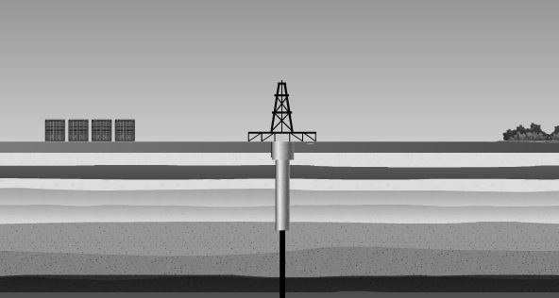

Hydrocarbons – The gaseous fuels extracted from the well. The biggest component is methane.
Proppant – A solid material, such as sand, that is injected to keep the fractures in the shale open.

Step 1 – Drilling

- Label the derrick and water table on the diagram above.

- What is the purpose of the derrick?

- What is the range of depths that groundwater is found in?

Step 2 – Vertical Drilling Phase

- Label the casing in the diagram above.

- What is the casing made of? Why is it there?

Step 3 – Drilling Continues

- How deep are the shale rock formations that the natural gas is found in?

Step 4 – Kick Off Point

- What is the kick off point?

Step 5 – Horizontal Drilling

- How long does the horizontal section of the drill travel?

Step 6 – Perforating the Well

- Why does the well need to be perforated?

Step 7 – Completion Phase

- Why is so much water needed during this phase?

- What is supposed to happen to the water that flows back up to the surface?

Step 8 – Hydraulic Fracturing

- What is actually “fractured” during hydraulic fracturing?

Step 9 – Hydrocarbons released
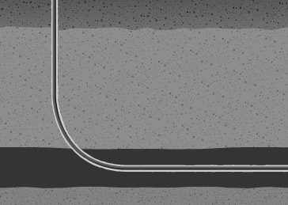
- Show what horizontal drilling part of the well now looks like by drawing the fractures and hydrocarbons on the diagram.

Fracking Map
Look at the fracking map at the Earth Justice Website: goo.gl/1PE45
earthjustice.org/features/campaigns/fracking-across-the-united-states

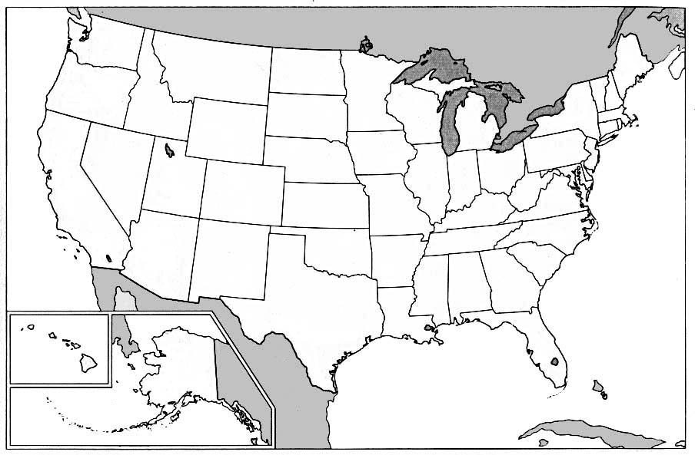

- Shade in any areas of active fracking and proposed fracking in your state. Use a different color for each.

- List five states that have the largest active fracking areas.

- List the five states with the largest number of fracking accidents labeled on the map.

- What is the closest “fracking accident” to where you live?

  - Summarize what happened during this accident.

- One of the most-affected towns by hydraulic fracturing accidents is Dimock. Find it on the Earth Justice map (look in Eastern Pennsylvania) and label it on your map above.

- Read the first page of the Vanity Fair article A Colossal Fracking Mess about what happened in Dimock. (The link is available if you click on the Dimock fracking accident label)
- Outline what happened to the drinking water at the home of Craig and Julie Sautner. What did Cabot Oil and Gas do to try to alleviate the problem?

- Visible effects on the water –

- Health effects experienced by the family –

- Actions taken by Cabot Oil and Gas –

- Actions taken by the Pennsylvania EPA –

- Hydraulic fracturing, as explained by the Halliburton website, should not contaminate water. Yet in the case of Dimock, it clearly did. Explain, based on what you’ve read, whether you think fracturing should be allowed at all, and if so, what specific regulations should be in place to prevent these kinds of accidents.

