Switch

Directions: Answer the following questions based upon the documentary.

Coal

- How much of the United States’ electric generation comes from coal? How much supply remains?

- The power plant shown uses five trainloads of coal per day, every day. Why is coal such an attractive source of electricity?

- What are the external problems caused by burning coal for electricity?

- Clean coal is a technology that captures and sequesters the pollutants released by burning it. Why isn’t this technology used in all coal plants?

Oil

- What are two factors that can influence the price of oil?

- What is a spar platform?

- How long does it take to set up a spar drilling rig?

- What happens at an oil refinery?

- Gasoline is described in the documentary as a “miracle” fuel. Why is it so ideal for transportation?

- How much U.S. oil demand is represented by the large oil tanker?
Biofuels

- What advantage do biofuels have within our current system?

- What is the most commonly used source of biofuel?

- What is the advantage of using plants high in cellulose like sorghum and switchgrass instead of corn?

- Switchgrass can be grown on “marginal land”. What is marginal land?

- The biggest problem with using biofuels is “scale”. Explain what this means.

Compressed Natural Gas

- Explain how natural gas is a cleaner fuel than diesel.

- Natural gas is a cheaper fuel than diesel, but it has higher capital costs. What does this mean?

Oil Sands

- Compare the consistency of oil present in the tar sands of Canada with typical petroleum.

- Explain how oil is extracted from the sands.

- If oil from the Canadian sands is so difficult to extract, why does Conoco Phillips bother?

Hybrid

- Why are we transitioning into hybrid cars instead of jumping straight to all-electric?

- What is the base price of the Tesla model shown?

- How much more electricity would need to be generated if all our vehicles were converted to electric?

Geothermal

- Explain how geothermal plants produce electricity.

- What waste product(s) are given off by geothermal plants?

- Explain how geothermal energy is a regional resource and dependent on geology.

Solar

- How long does it take homeowners who install solar panels to recover their investment?

- Solar energy is described as regional. What three variables must be at high levels in order for it to be economically viable?

- Diablo Valley College has a solar array above one of its parking lots. How much energy is produced by this array per year?

- How does concentrated solar heating work differently than photovoltaic cells?

Wind

- What advantage does wind power have over other renewable resources?

- The biggest problem with wind power is its intermittence. What does this mean?

- Explain why so many transmission lines have to be constructed to support wind farms.

- Based on the graph shown below, when are the peak times for electricity consumption?

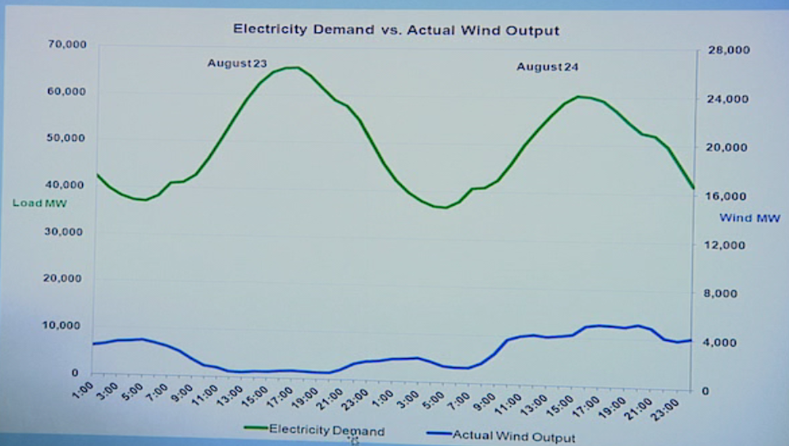

- What is wind power supplemented with in Texas to overcome its intermittence?

Hydrofracking

- Natural gas within shale formations normally cannot escape. How does hydrofracking change this?

- Name two big advantages of tapping into these deep shale formations.

- What is the single biggest problem with hydrofracking?

- Is water contamination more likely to occur from the deep well operations, or surface operations? Give an example.

- Natural gas is very difficult to store. How is the gas captured at sea between Iran and Qatar transported?

Nuclear

- What kinds of external damage can nuclear containment buildings withstand?

- What is the bigger hurdle in developing nuclear power: the cost of the plant, or the fuel?

- France gets 80% of its electricity from nuclear power. What do they do with the waste – the spent fuel rods?

Conclusion

- Scott Tinker discusses a 50-year “crossover”, where our use of alternative fuels for energy overtakes foundational fuels. What does he include in the foundational fuels graph? What does he include in the alternative fuels graph?

- Meeting the challenge of the 50-year crossover will require a tremendous amount of construction of renewable, nuclear, and gas-powered plants. What does Scott suggest is the best way to deal with this?

